GOOD UI and BAD UI
NAME: MAGESHWARAN M
ROLLNO:240701299

BAD UI
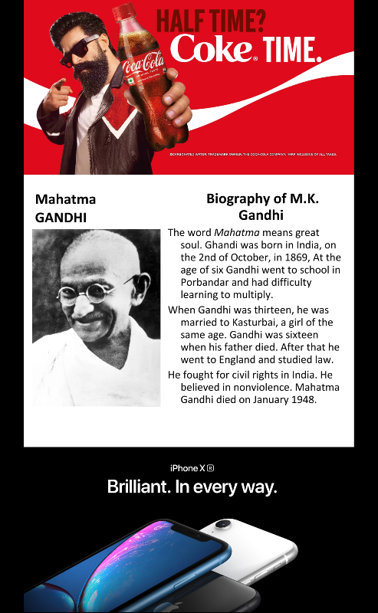

GOOD UI

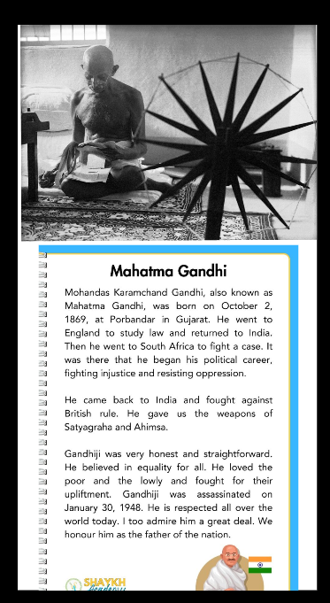

Feature | Website Without Ads (Good UI) | Website With Ads (Bad UI)
Focus | High. The user immediately finds the content they came for. | Low. The user has to "filter out" noise to find the actual content.
Visual Stability | High. Elements stay where they are supposed to be. | Low. "Layout Shift" occurs when ads load late and push content down.
Load Speed | Fast. Fewer scripts and external requests. | Slower. Ad networks often throttle page performance.
Trust Factor | High. The site feels professional and curated. | Low. Intrusive ads can make a site look "spammy" or unsafe.
Accessibility | Clear. Screen readers can easily parse the main text. | Messy. Screen readers may get stuck on ad descriptions or "Skip" buttons.

